**Contouring the Chestwall in RayStation**

**Purpose:** This procedure gives an easy way to contour the left or right chestwall in RayStation. This is usually only necessary in SBRT lung cases.

1. Use ROI algebra to create the initial chestwall geometry:

2 cm lung expansion P, A, and L or R (same side as lung)

minus

2 cm lung expansion P, A, and L or R (opposite side as lung)

For right chestwall:

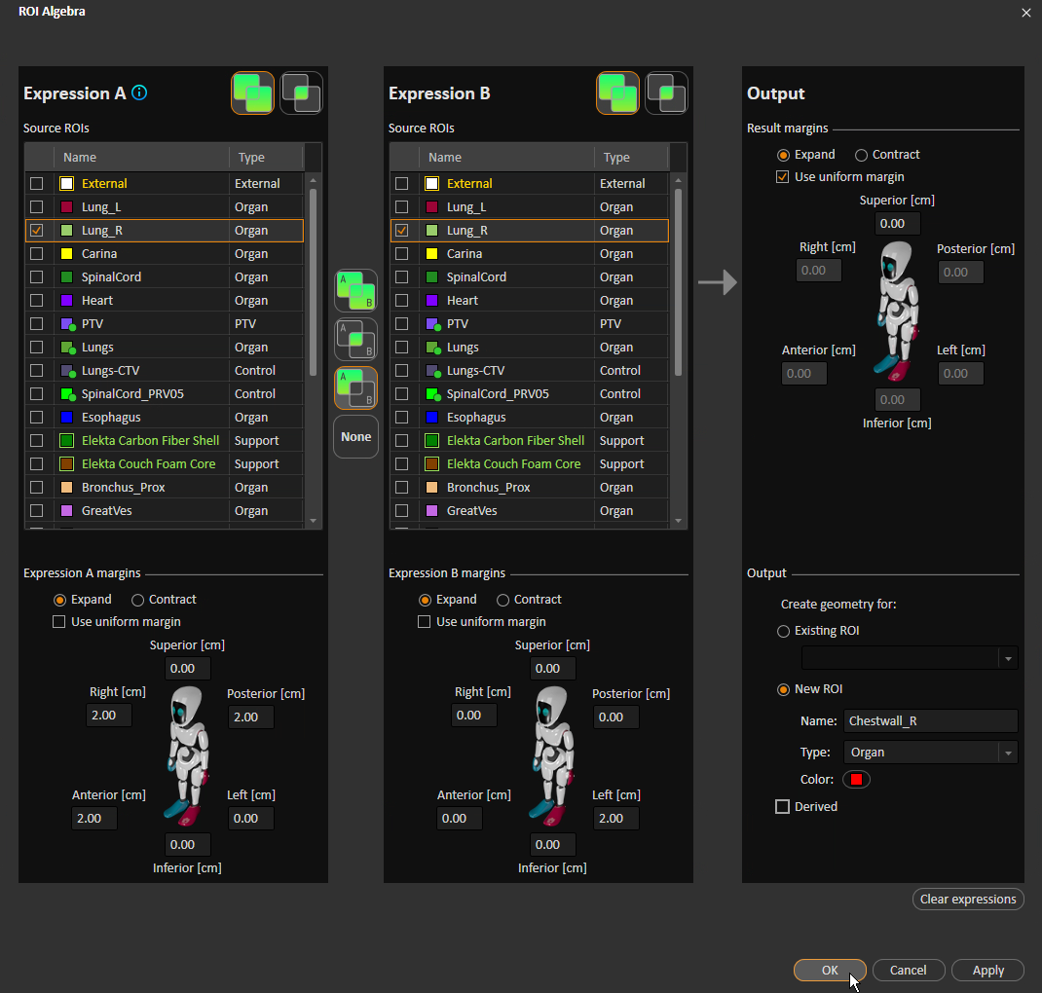For left chestwall:

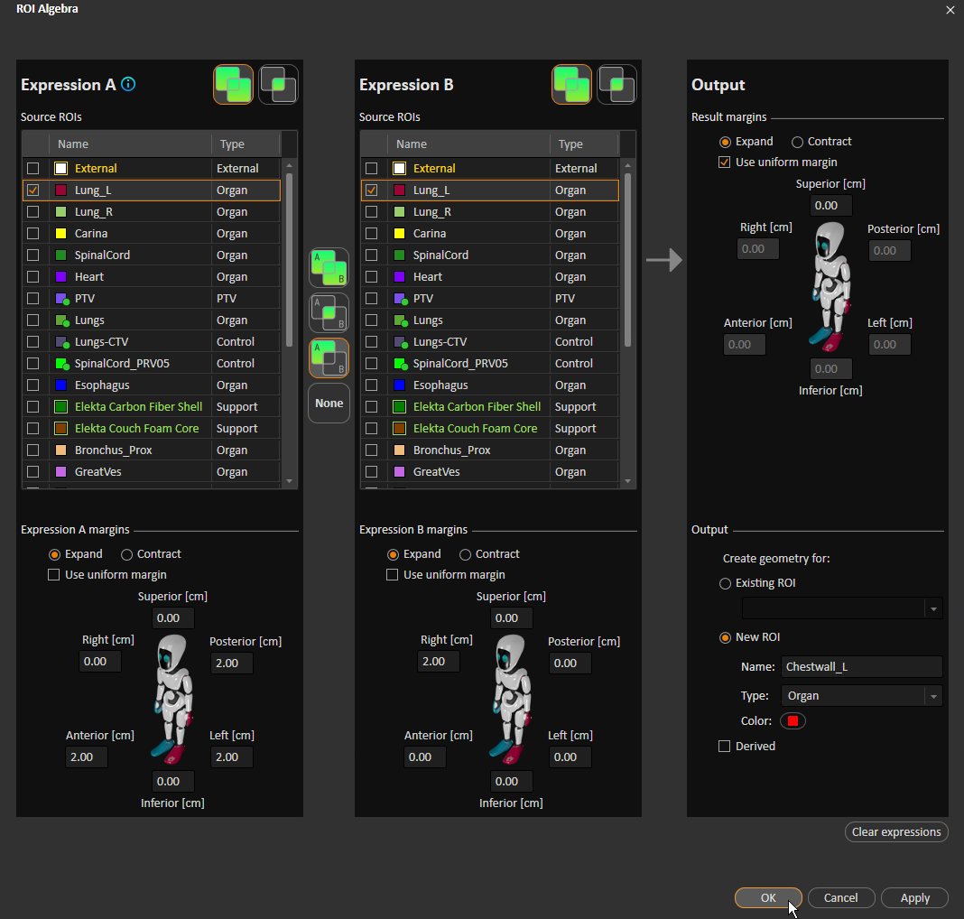

1. Use ROI algebra to intersect the chestwall with the skin. For SBRT, this is usually Skin, Skin Surface, or External No Box. Otherwise, it is usually External.

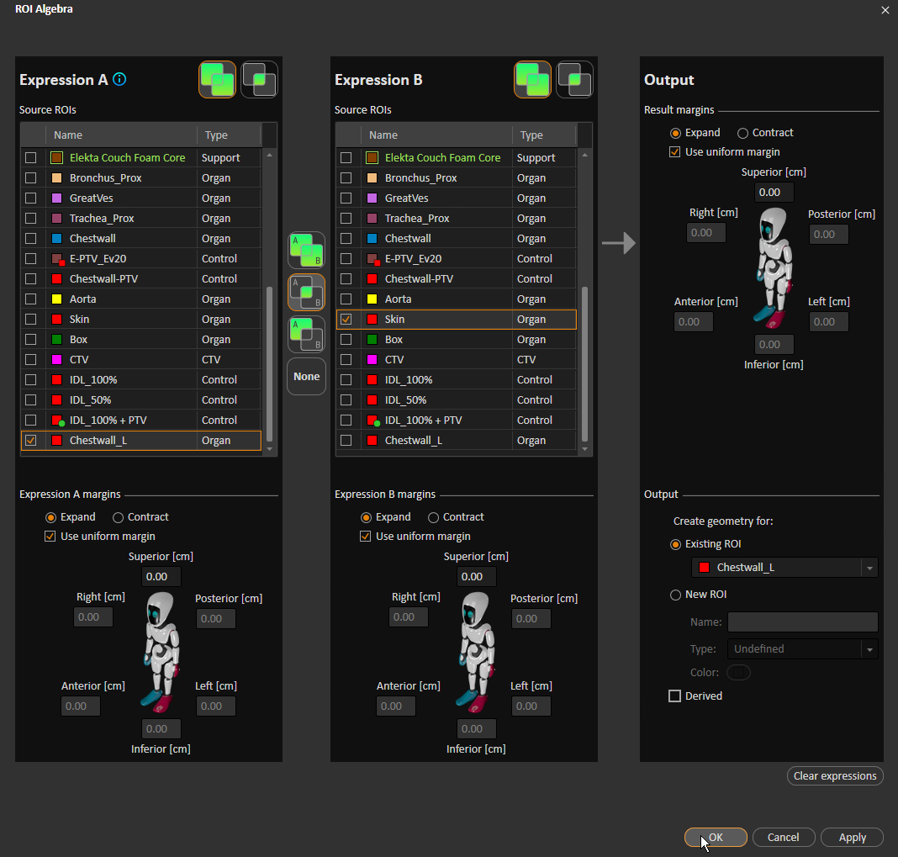

1. Starting superiorly, fine tune the chestwall contour as necessary. Of course, accuracy is less important once you get around 2 cm away from the lung.

Near the inferior edge, it is necessary to remove “protrusions” (see below image).

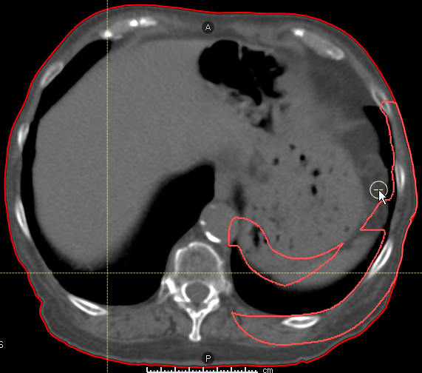

1. Stop at the most superior slice with two large, distinct chestwall pieces.

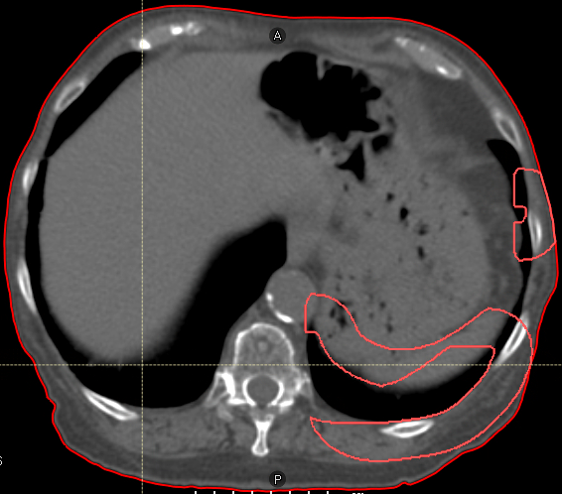

Erase the chestwall contour on this slice.

1. Scroll back above this slice. Use the **Keep Component** tool to remove extraneous pieces of the chestwall contour.
   1. Click **Keep Component**.

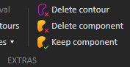

* 1. Click the large piece of the chestwall contour.

